1.
1. Scan Common Ports
Command: nmap 192.168.1.1
Purpose: To scan commonly used ports on the target device.
Content:
This command is used to scan the target IP address 192.168.1.1 for commonly used ports. It helps identify which ports are open, closed, or filtered. This information is useful for understanding the network services available on the target device.
Result:
The Nmap scan displays the detected port numbers, their states, and the associated services.

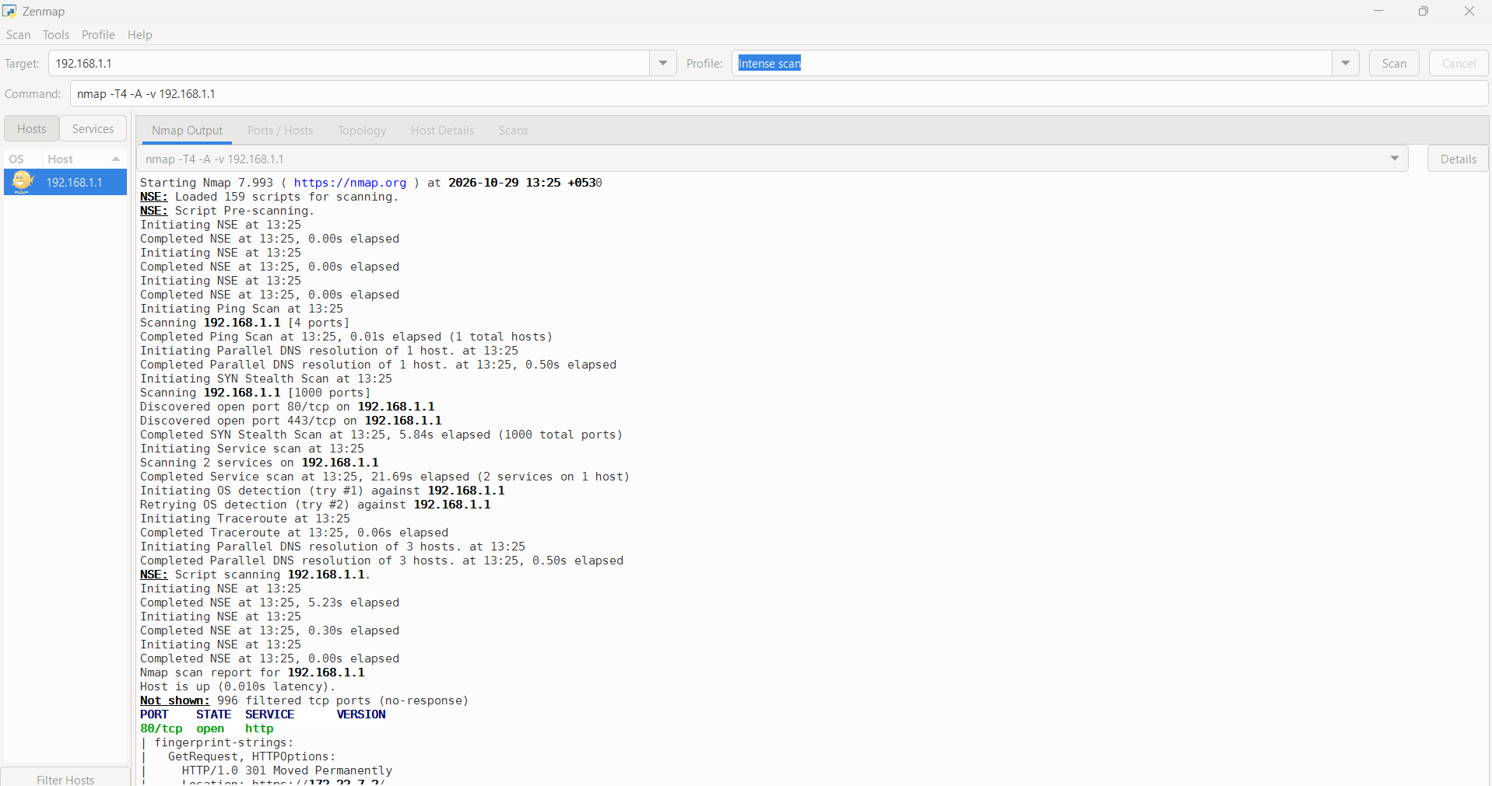
2. Discover Live Hosts
Command: nmap -sn 192.168.1.0/24
Purpose: To discover active devices in the network.
Content:
This command is used to discover live hosts in the 192.168.1.0/24 network. It checks which devices respond to Nmap's host discovery probes without performing a port scan. It helps identify active devices connected to the local network.
Result:
The output displays the hosts that Nmap identifies as online.

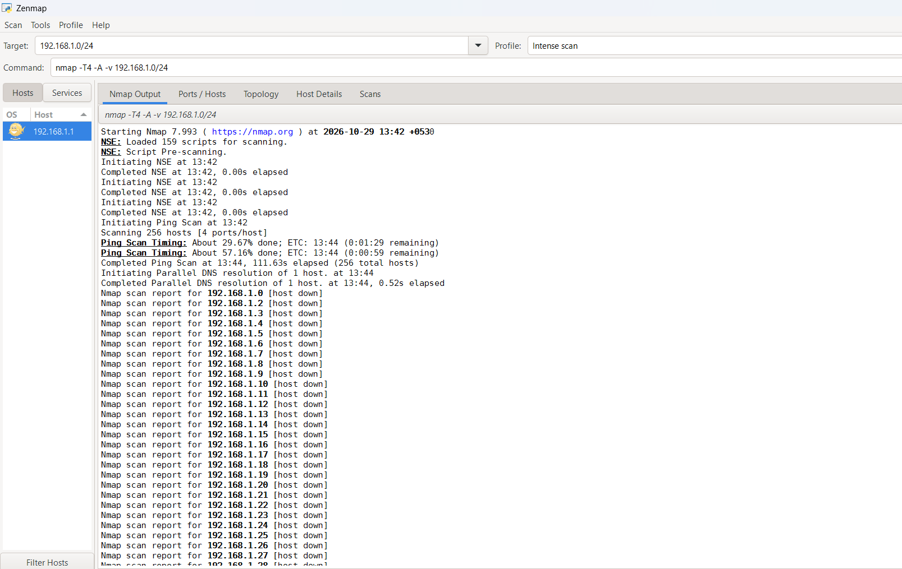
3. Detect Service Versions
Command: nmap -sV 192.168.1.1
Purpose: To identify services and their versions.
Content:
This command is used to detect services running on open ports of the target device. The -sV option helps identify service names and, when possible, their software versions. This information is useful for network inventory and security analysis.
Result:
The scan displays detected open ports, service names, and any identified version information.
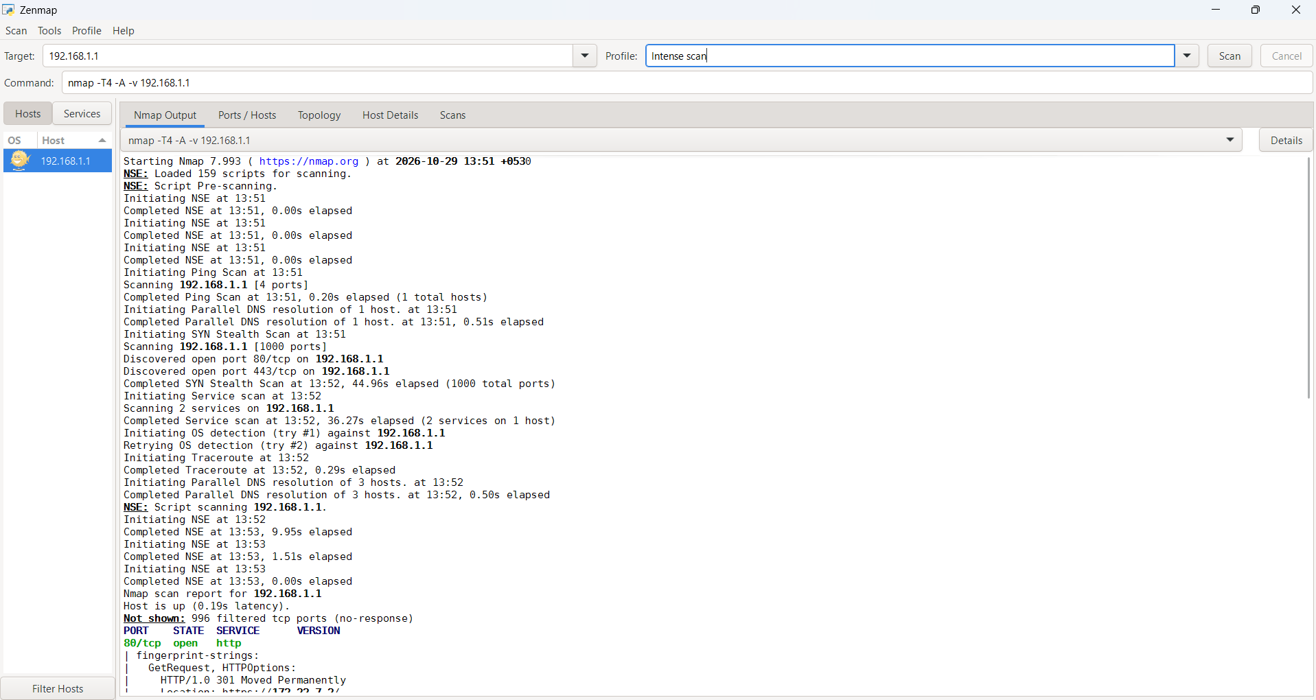

4. Identify the Operating System
Command: nmap -O 192.168.1.1
Purpose: To estimate the target operating system.
Content:
This command uses operating system detection to estimate the operating system of the target device by analyzing its network responses. The -O option performs OS fingerprinting. The accuracy depends on the available network responses and scan conditions.
Result:
Nmap may display the estimated operating system and related fingerprint details.

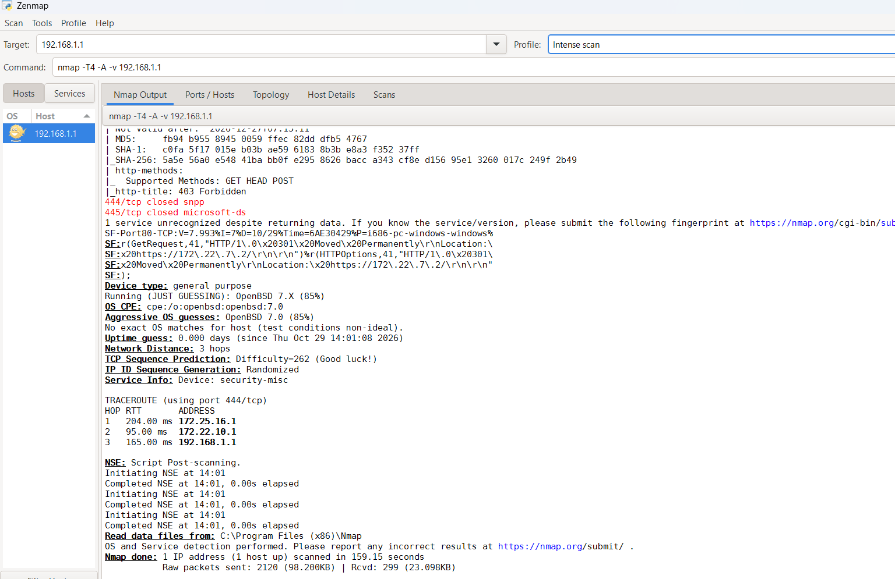

5. Scan Specific Ports
Command: nmap -p 80,443 192.168.1.1
Purpose: To scan selected ports.
Content:
This command scans only ports 80 and 443 on the target device. Port 80 is commonly used for HTTP, and port 443 is commonly used for HTTPS. It helps check the availability of these commonly used web service ports.
Result:
The output displays the detected states of ports 80 and 443.
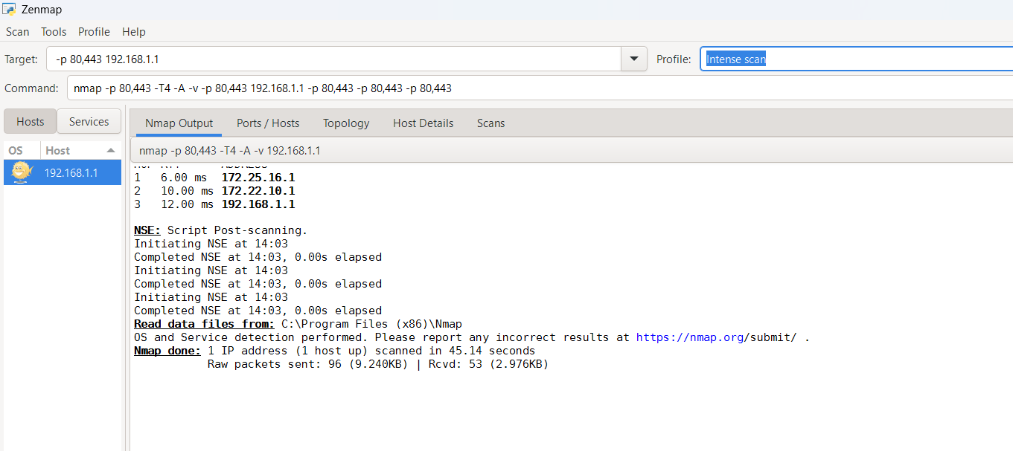

6. Run Default NSE Scripts
Command: nmap -sC 192.168.1.1
Purpose: To run default Nmap scripts.
Content:
This command runs Nmap's default NSE (Nmap Scripting Engine) scripts against suitable discovered services. These scripts can collect additional information about the target and its services. Script results depend on the services detected and the scripts executed.
Result:
The output may contain additional service information and script results.

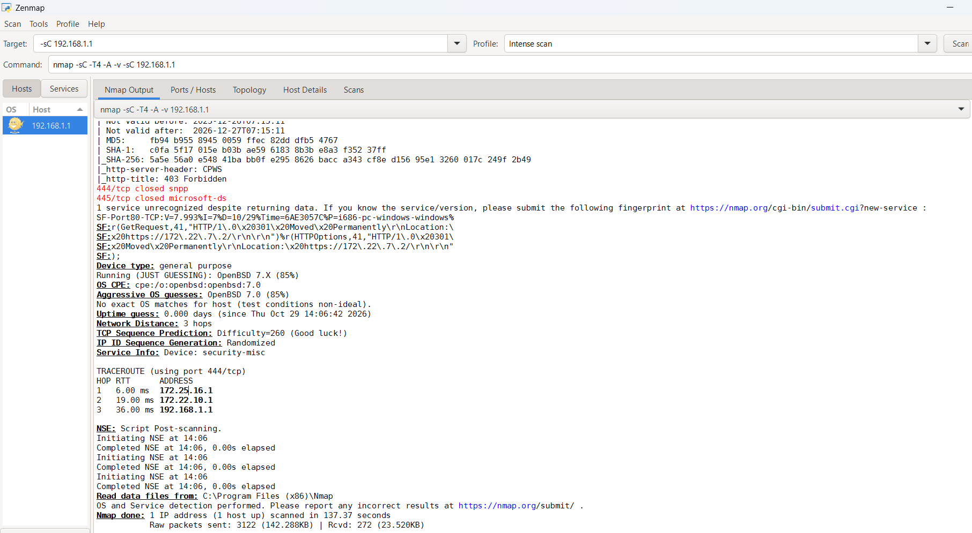
7. Skip Host Discovery
Command: nmap -Pn 192.168.1.1
Purpose: To scan a target without host discovery.
Content:
This command skips the normal host discovery stage and treats the target device as online. It is useful when host discovery probes are blocked by a firewall or the device does not respond to them. Nmap then proceeds with the requested port scanning.
Result:
The output displays the scan findings even if the target does not respond to the usual host discovery probes.
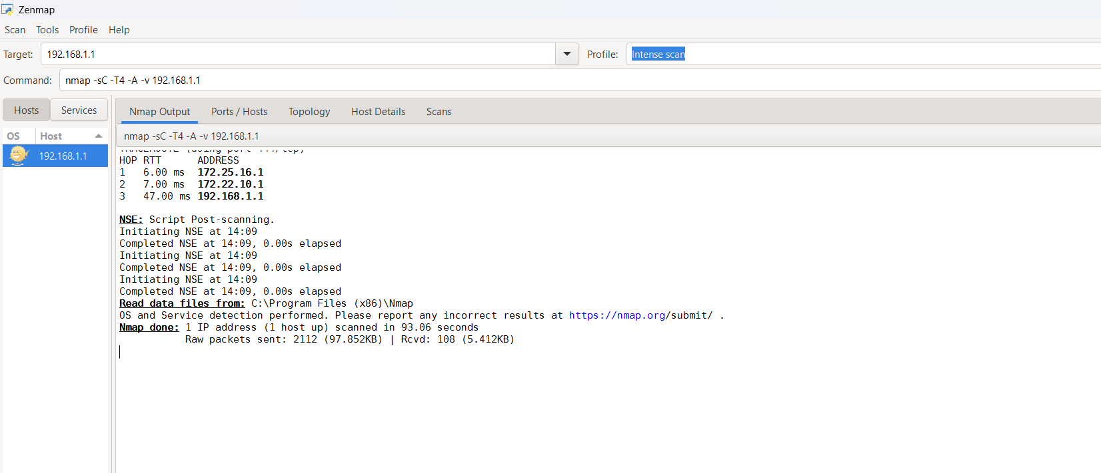

8.

